ST. AUGUSTINE OF CANTERBURY
HECKER, ILLINOIS 62248
REV. VON C. DEEKE, PASTOR
PARISH OFFICE 473-2217 FAX 473-9141
E-MAIL ADDRESS: staug@htc.net
PARISH WEBSITE: staugustineofcanterburyhecker.weebly.com
To contact Father Von when not in Parish Office, Cell #618/214-6852
St. Vincent de Paul Help Line 618/792-4059
House of Neighborly Service Help Line 618/939-8680
Confessions: are heard each Saturday night from 4 to 4:45 pm and each Sunday from 8 to 8:20 am.
Parish Office Hours: Mondays and Thursdays, 9:00 am to 4:00 pm. Closed from 12 noon to 1:00 pm for lunch.

VOL. 54 NO. 35 – SEPTEMBER 1st, 2019

THEME FOR THE TWENTY-SECOND SUNDAY IN ORDINARY TIME: Humility and self-knowledge go hand in hand. Those who conduct their affairs with humility shall be exalted, while those who exalt themselves shall be humbled. The humble shall rejoice and exalt before God in the assembly of the heavenly Jerusalem.


MASS INTENTIONS:

Sat. 8-31 5:00 pm – For Our Parish at St. Augustine’s
Sun. 9-1 8:30 am – Phillip Rheinecker
Tues. 9-3 8:00 am – Virgil Gregson
Wed. 9-4 8:00 am – Don Bruss
Thurs. 9-5 8:00 am – David Braun & Irene Sturgeon
Fri. 9-6 8:00 am – Darrell Grohmann
Sat. 9-7 5:00 pm -- For Our Parish at St. Augustine’s
Sun. 9-8 8:30 am – Walter & Anne Amann

ORGANIZATIONS
BLESSED VIRGIN ALTAR SODALITY – The ladies meet the first Tuesday In September, November, January & March at 7:00 pm in the Parish Center. Details regarding the annual Christmas Party and Spring Breakfast are shared in the bulletins closer to those dates.
KNIGHTS OF COLUMBUS – meet the second Wednesday of every month at 7:30 pm in the Parish Center. Any changes or special activities are given elsewhere in the bulletin.
QUILTING – ladies meet to quilt each Tuesday in the Parish Center from 8:30 am to 3:30 p.m. except during the summer. Any questions call Margie Holle at 473-2944 or Alice Kuehn 473-2817.

PARISH COUNT: 180
OUR SACRIFICE MADE TO GOD: 8-25-19
Sunday Envelopes (55) - $2,582.00
Loose - $173.00 Youth (2) - $13.00

Scholarship Fund - $15.00

(Total Donated since 8/1/2019)

Thank you very much for your generosity!

SCHEDULE FOR THE WEEK

Saturday, September 7th; 5pm Sunday, September 8th; 8:30am
Ushers: Ed Schaefer Ushers: Ralph Eckart & Scott Gregson
Greeters: Cindy Grohmann Greeters: Haudrichs
Servers: Koesters Servers: Murphys
Lector: Ruth Wittenauer Lector: Kay Haudrich
Extraordinary Ministers: Barb Bruss Extraordinary Ministers: Dale Haudrich,
John Kaiser and Alice Kuehn Marvin Parker and Angie Parker

OFFERTORY FAMILIES
Sat. 9/7 – M/M Dave Bruss Sun. 9/8 – Dorothy Christiansen & Kay Rist
Sat. 9/14 – Mary Ann Bruss Sun. 9/15 -- Arnie Eckart Family
Sat. 9/21 – M/M Mike Gregson Sun. 9/22 -- Bernadette Gregson
Sat. 9/28 – M/M Marvin Gregson Sun. 9/29 – Scott Gregson Family
Sat. 10/5 – Carey Day Family Sun. 10/6 – Cindy Grohmann
Sat. 10/12 – Geri Griffin Family Sun. 10/13 – Richard Happel Family


Please pray for the following:

Darlene Frisch, Ellen Daniels, Dave Bruss, Aaron & Dorothy Vogler, Janet Hayes, Maxine Linnertz, Kathy Lynn Kromat, Ray Mavers, Robert & Alice Mueller, Bob Dennler, Bob Reed, Pam Wilderman Woodward, Shirley Wittenauer, Madalyn Killebrew, Stephanie Amann Stosberg, Ranetta Adams, Nancy Grohmann, Sheila Zubrzyski, Lowell Powell, Renee Krebel, Kristen Christ, Bonnie Casey, John Joseph Materniak, Beverly Moskop, Ruth Cortner, Lois Papenberg, David Williams, Diane Guttmann, and Mathew Myers.

Submitted names will remain on the prayer list for one month’s time. Please call the Parish Office 473-2217 to submit names for the prayer list.

BLESSED VIRGIN ALTAR SODALITY MEETING
TUESDAY, SEPTEMBER 3rd, 7:00 PM
PARISH CENTER
All ladies of the parish are encouraged to attend! Lots to discuss & plan!

There will be a Holy Hour of Eucharistic Adoration following the 8:00 am Mass on Friday, September 6th,
from 8:30 to 9:30 am.


DIOCESAN
EVENTS

RESPECT LIFE CORNER

“The Church has consistently taught that every human life is precious and worthy of protection.” USCCB Secretariat of Pro-Life Activities
May the life of every human person, from conception to natural death, be protected in our laws and cherished in our hearts.

Part-Time Accounting/Bookkeeper Position Available

The Society of St. Vincent de Paul Belleville Council, a Catholic, non-profit 501c-3 that serves the poor, has a part-time bookkeeper/accounting position available at the Council Office. This experienced candidate must be proficient with Quick Books Pro, accounts receivable/accounts payable, payroll/payroll taxes, financial reports, budget preparation and enjoy interacting with people. The position would be ideal for a retired individual. If interested in applying, please call 618-394-0126 and leave a message or text 618-799-8505.

In September, there are 5 Sundays; so once again, we will conduct a 2nd Collection at Masses the weekend of, September 28th and 29th. This collection will benefit St. Vincent de Paul (Waterloo) and the House of Neighborly Service for their 2019 Holiday Outreach Programs. We appreciate your generosity during these 5th Sunday Collections. Once again, if you wish to have your donation listed on your annual financial statement, please indicate on your check memo line or put cash in an envelope with the designation of 5th Sunday Collection. And although there are five weeks during the month of December, there will NOT be a 5th Sunday Collection. Thank you!

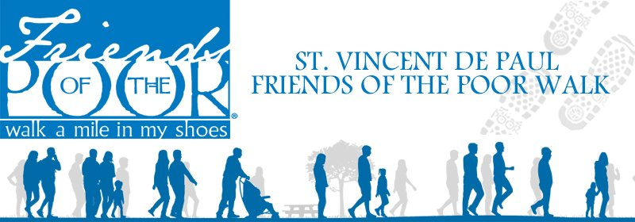
Join us for the Annual
St. Vincent de Paul Friends of the Poor® Walk
Saturday, September 21, 2019
National Shrine of Our Lady of the Snows
Register and Walk Anytime Between 8:00 a.m. – 12 Noon
Free donuts/juice/water for all
Choice of T-Shirt, water bottle, rally towel or drawstring backpack for all participants
100% of funds raised go directly to serve the poor!
Walkers and Walk Sponsors Needed Now!
For additional information call 618-394-0126

COMING AREA EVENTS

FLYERS WILL NOW BE LOCATED IN A 3-RING BINDER AT THE FRONT ENTRANCE TO CHURCH. FEEL FREE TO CHECK OUT THE BINDER IF YOU NEED ADDITIONAL INFO ABOUT AN EVENT.

Sept. 3rd – Noon Luncheon; St. Luke’s Belleville; $8; Cards, Bingo etc; Serving Frank & Bun, Potato Salad & Baked Beans
Sept. 6 & 7 – Fall Festival; St. Stephen, Caseyville; Quilt/Cash Bingo at 6:30 both nights; 4pm Mass; Dinners, Games, Auctions, Booth Games etc.
Sept. 6 & 7 – Parish Picnic; St. Joseph’s Freeburg; Fri: Fish fry 4-7pm; Music 7-10; Sat. 4pm Mass; Chicken Dinner 4-7; Quilt Bingo 6pm; Music 5-11:30pm; Games, Raffles, Kids activities.
Sept. 8th – Quilt/Cash Social; St. James Millstadt; 1pm; Doors open 10:30am; Fried Chicken Dinners, Refreshments; Basket Boutique & Bake Sale Items; Donate 1 canned good & get 1 free card per tally; BYOC
Sept. 14th – Picnic; St. Augustine’s, Belleville; 4-11pm; 4pm Mass; Dinner 3-6:30pm; Quilt/Cash Bingo 7pm;
Saloonatics 7pm; Games & Rides for Kids; Stands etc.
Sept. 15th – Designer Purse Bingo; St. Agatha Parish Hall, New Athens; Doors open 11:30 am; Bingo starts 12:30pm; $40 advance/$50 at door; Includes 10 games of bingo, dabber, soda, wine, & mixed drink; Bring Your Own Snacks, 50/50 raffle; Call Katie Waeltz 618/475-2170 or kwaeltz@stagathaparish.com or online at Glo-bingo.com.
Sept. 22nd – Dinner/Quilt Raffle; Our Lady of Good Counsel, Renault; Dinner 11am-4pm; Bags Tournament beings 12 noon/$20 per team; call Lisa 618/458-7799 to enter; Quilt Drawing 4pm; beer stand, kids games.
Sept. 29th – Quilt/Cash Bingo; Sr. John’s Red Bud; Dinner 11am-1:30pm; Bingo 2 pm; Basket Raffle.
BINGO - BINGO - BINGO on Monday nights at CKL of I in Swansea. Bingo (no machines) begins at 7pm and proceeds benefit Althoff Catholic High School. Food and drinks are available
Euchre -- Every Thursday afternoon starting at 1:00; St. Michael’s Paderborn.
Society of St. Vincent de Paul
St. Elizabeth Ann Seton Conference

We are a Catholic lay organization providing service to the needy and suffering.
Our Conference includes the parishes of:
- St. Augustine of Canterbury-Hecker
- St. Mary-Valmeyer
- St. Patrick-Tipton
- Saints Peter & Paul-Waterloo
Telephone numbers are 939-0605 and 618-792-4059
Mailing address is P.O. Box 443, Waterloo, IL 62298
Meetings are held on the first Tuesday of the month at Adult Faith Formation House at 7:00 PM. New members are always welcome.

SEXUAL ABUSE HOTLINE:
Anyone wishing to report an allegation of sexual misconduct by a priest or other diocesan personnel please call the hotline:
800-640-3044.

Purchase SPPCS “Scrip Cards” for your shopping and gift giving needs!
Scrip cards make great gifts and in addition, consider purchasing “scrip cards” to use in place of cash, checks or credit cards for purchases you make.

How does that help St. Augustine families? Each SPPS student family is required to earn $250 each year in fund raising. Plus, each student must pay $400 registration and book fees. Then the tuition begins. At the end of each month the rebates from scrip sales are tabulated and applied to the family’s account. You may designate a particular family or St. Augustine students as a group in which case it will be equally divided. Order forms are located in magazine rack in front vestibule of church. Please consider trying this program and perhaps add an item each month to help our parish support the SPPS/St Aug. families with absolutely no cost to you. Order forms may be returned in collection basket with check or given to Betty or Annette Schreder or any SPPS student family. Any questions may be directed to same people.

Have The Messenger
delivered to your door.
Subscribe Today!
Call: 618-235-9601
Email: subscribe@belleville
messenger.org
Mail your request:
The Messenger
2620 Lebanon Ave.
Belleville, IL 62221
Meet us on the web: www.bellevillemessenger.org



The annual Parish Council Elections will be conducted at the weekend Masses on October 5th and 6th, 2019.

Nomination slips are attached to the bulletins this weekend and are to be returned NEXT WEEKEND September 7th & 8th.

Dawn Grohmann is completing her first term on the council and is eligible for nomination and re-election. Kevin Kreher is completing his second term on the council and is not eligible for nomination and re-election.

The following are not eligible for nomination because they are already members of the Parish Council, or are members of the Finance Committee, or are officers in parish organizations, or are Parish Trustees. Please do not nominate the following:

Walter Krysnoski-Trustee Larry Schaltenbrand-Trustee
Debbie Harbaugh-Sodality Ralph Eckart-Holy Name
Annette Schreder-Sodality Chuck Wagner-Holy Name
Roger Cortner-Cemetery Rep. John Kaiser-Holy Name
Joan Powell-Finance Dale Papenberg-Finance
Carrie Koester-Finance & SSPPCGS Board
Clinton Mudd-Finance Vicki Biffar-Parish Council
Kyle Doerr- Parish Council Kay Haudrich-Parish Council
Brian Smith-Parish Council

At this time, registered members (18 years and older) are asked to submit their nominations for election. Please write the names of two (2) women and two (2) men on the nomination slips that will be attached to the bulletin this weekend. Please take the nomination slips home, fill them out and return in the collection basket the NEXT WEEKEND SEPTEMBER 7th & 8th. If your household needs an additional nomination slip, extras are available in back of church.

If you have any questions, please contact the office at 473-2217.

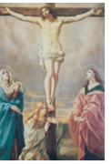
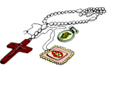

The Fifth Sorrowful Mystery
THE CRUCIFIXION
- The hands and feet of Jesus are nailed to the cross in the presence of His afflicted Mother.
- "Father, forgive them for they know not what they do."
- "This day you will be with Me in paradise."
- "Woman, behold your Son. Son, behold your Mother."
- "My God, My God, why have You forsaken Me?"
- "I thirst."
- "It is finished."
- "Father, into Your hands I commend My spirit."
- The side of Jesus is pierced with a lance. His body is taken down and placed in the arms of His Mother.
- Father, by the merits of the crucifixion and death of Jesus, have mercy on us and on the whole world.
Spiritual Fruit: pray for the students and teachers returning to school, that it will be a successful year for growth in knowledge, may all grow in faith and respect for all.

REQUEST FOR PHOTOS FROM ST. AUGUSTINE’S SCHOOL CLASSES…

Yes, I am once again working on this project after quite a delay. I have listed below the grades per year that I am looking for. If you have any of these pictures, I would truly appreciate being able to borrow them so that I can scan them and save them on the computer. Then eventually I will get them printed and framed into a collage to display in our Parish Center. Thank you for your assistance!
Joan Powell

NEEDED:

Any from 1900-1933…just have one picture each from 1934 & 1936.

All grades from the 1940’s

1950’s – need all grades from 1951-1956

1960’s – 1960 all grades 1980’s – 1980-81 need Grades 3 & 4
1962-63 need Grades 3 & 4 1981-82 need Grades 1 & 2
1964-65 need Grades 1-3 1982-83 need Grades 5 & 6
1965-66 need Grades 5 & 6 1983-84 need Grades 3 & 4
1966-67 need Grades 3 & 4 1984-85 need Grades 7 & 8
1967-68 need Grades 5-8 1985-86 need Grades 1 & 2
1968-69 need All Grades 1986-87 need Grades 1 & 2
1969-70 need All Grades 1987-88 need 1-2 & 3-4
1988-89 need 1-2 & 3-4
1970’s – 1970-71 need All Grades 1989-90 need 3-4 & 5-6
1971-72 need All Grades
1972-73 need All Grades 1990’s – 1990-91 need 3-4 & 5-6
1973-74 need Grades 7 & 8 1991-92 need 5-6 & 7-8
1975-76 need Grades 5 & 6 1992-93 need 5-6 & 7-8
1977-78 need Grades 7 & 8 1993-94 need Grades 7-8
1978-79 need Grades 1 & 2 1995-96 need Grades 5-6




The Catholic Service and Ministry Appeal 2019
…Blessed to receive, chosen to give
Griffin Center, an agency that receives funding from The Catholic Service and Ministry Appeal, provides after-school and summer programs free of charge to 450+ children who live in public housing. With an emphasis on learning, homework assistance, computer labs and tutoring, Griffin Center gives these youngsters a chance for a brighter tomorrow. Be a part of their dreams and make your gift to this year’s Appeal today

Our parish participation goal for the appeal is 58 households and our financial target is $6,000.00. Please be as generous as you are able.

Pledges to Date: 39 $6,205.00 103% of Total Goal

As our country honors Labor this weekend, we can rejoice in our Labor for the Lord. We reflect on how we are spreading the Word and how we are promoting our Catholic Church. This is the vocation of ALL of us. We have our role in praising our God, in sharing our Faith and in educating our families in the ways of the Lord. We need to encourage our family members to be attentive to their call – maybe even to the priesthood or religious life.



HAVE YOU HEARD OF SERRA CLUB? The Serra Club of St. Clair County is an organization of Catholic men and women, dedicated to foster and affirm vocations to the Priesthood and vowed religious life. Our purpose is to inform our community of the need for all vocations. We honor our religious with an annual Nuns Luncheon, a Deacon Dinner, a Priest Picnic and a new Priest Dinner. We pray for our seminarians and help them celebrate their birthdays.
Our club meets every first and third Friday of the month. There is a Mass, lunch, a speaker and a brief meeting. You are welcome to join us as our guest. For more information please contact Marvin Winkeler (402-214-1155) or Mel Lucash (618-531-4244)
HELP US PRAY FOR VOCATIONS!



NEWS FROM GIBAULT CATHOLIC HIGH SCHOOL…
Happy Labor Day weekend from Gibault Catholic!
Drive in Style
Join the Gibault community for the Ford Drive and BBQ Fundraiser, sponsored by the Gibault Men’s Club. Sunset Ford will donate $20.00 to GCHS for each qualified test drive (drivers must be 18+; limit one qualified driver per address.) What: Gibault Men’s Club Ford Drive and BBQ Fundraiser; When: Saturday, September 7 (9AM-4PM); Where: Gibault Gym Parking Lot
Mark Your Calendars- Gibault Oktoberfest Dinner and Auction -- Join us in Gibault’s Hustedde gym on Saturday, October 26 for an evening of good food and fun. This year’s theme is Glitz and Ghouls, and it is sure to be an event you don’t want to miss! Mass: 4:15PM; Doors Open: 5PM; Dinner: 6:30PM
Be a Hawk for a Day
Shadow season begins at Gibault Catholic on September 3! Follow our modular schedule, attend classes, eat lunch, learn about clubs, and more, all alongside a current GCHS student. Contact Kara Hoke (khoke@gibaulthawks.com)for more information and to arrange your 7thor 8thgrade student’s shadow visit.
GCHS Bi-monthly E-newsletters
Gibault sends out bi-monthly electronic newsletters with videos, pictures, news, and events! Don’t receive these? E-mail Kara Hoke (khoke@gibaulthawks.com)to be added to our list, and please note your alumni year, if applicable!



SPPCS Mass on the Grass (picture attached)
SPPCS held its annual Mass on the Grass on August 23rd at the SPPCS Fields.
Waterloo Homecoming Parade (pictured attached)
SPPCS Families walked in the Waterloo Homecoming Parade on Saturday August 24th. The students handed out candy, beaded necklaces, SPPCS pencils and flyers to the spectators along the parade route.
Save the Date - our Annual Grandparents Day Celebration Mass with be held on Friday September 20th at 9 a.m. We look forward to seeing everyone there!
Other dates:
September 14th - SPPCS PTO Movie Night at the SPPCS Fields - Dinner at 6:30 PM, Movie at Dusk
September 19th - SPPCS Lifewalk at 2 PM
October 12th - PumpkinFest - SPPCS PTO Sponsored 5K/10K/Fun Run & SPPCS Athletic Booster Club will have their Chili stand.



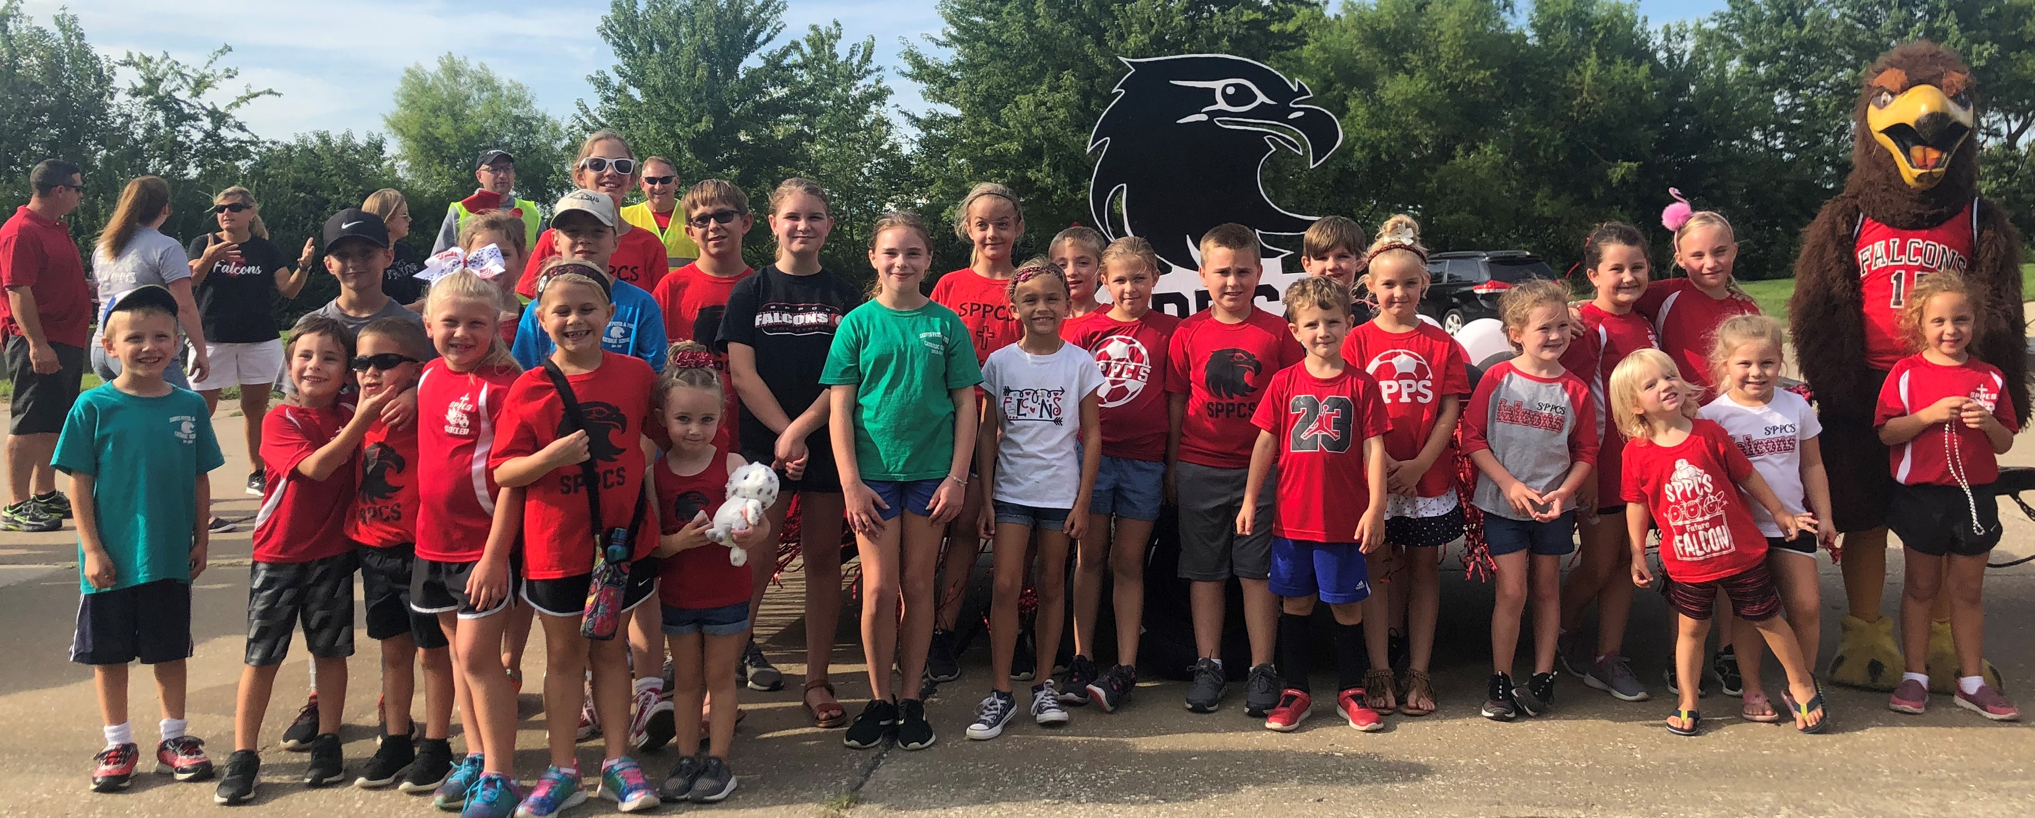
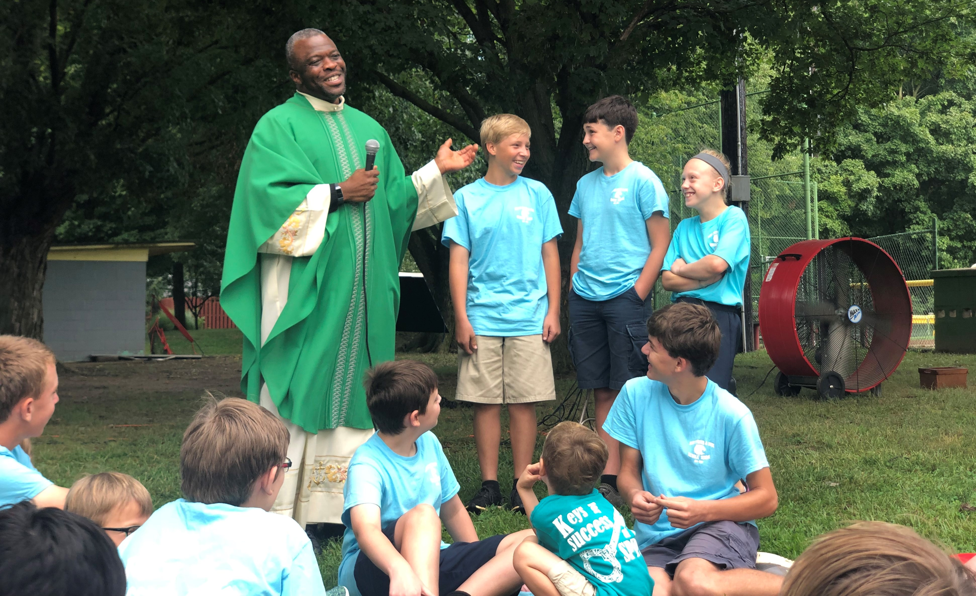

PARISH SCHOOL OF RELIGION (PSR) NEWS –
SS. PETER & PAUL, WATERLOO

PSR information for the 2019-2020 school year has been updated on Ss. Peter & Paul’s website. Please take a few minutes to look over all the details. http://www.ssppcc.org/PSR
Volunteers are needed for the 2019-2020 School Year. Weekly and non-weekly volunteers are needed to make the year a success. Catechists are especially needed in grades 6 & 7. For more info or to volunteer visit: http://www.ssppcc.org/psr-volunteers.

For more information regarding the PSR program, please contact Catherine Burkart, the PSR Coordinator, at psrnews@gmail.com.




The Youth Ministry of Ss. Peter and Paul which also includes the youth from St. Augustine’s now has a new social platform…INSTAGRAM! The new Pastoral Associate of Youth Ministry, Mrs. Catherine Burkart, has set up an Instagram Account which she will use to promote prayer and social opportunities. Any youth interested can follow on ssppyouth_waterloo.

GroupMe. This is a new social media platform that the teens are using. It is a large group text option. Students can invite other teens to join or students can join by following the link below.

https://web.groupme.com/join_group/44062372/mlpvgk

WATERLOO
Queen of Hearts
BENEFITS SPPCS ATHLETIC DEPARTMENT
The SPPCS Queen of Hearts fundraiser is in full swing. $1 tickets are on sale at the Stubborn German Brewing Company in downtown Waterloo during normal business hours. Drawing is at 7:00 p.m. every Tuesday.
Please contact the school office for more information at 618-939-7217.
(You must register with the program before purchasing tickets.)




I will be out of the office on Thursday, September 5th and will be working Wednesday, September 4th instead plus additional hours earlier in the week. Signed: Joan Powell


The St. Augustine’s Choir will be singing during the 8:30 am Masses on Sunday, September 15th & Sunday, September 29th.

HAVE A SAFE AND
HAPPY LABOR DAY
HOLIDAY WEEKEND!!!!

The Sacrament of the Eucharist – The Sacramental Sacrifice: Thanksgiving, Memorial, Presence

Let’s continue seeing what is taught about the Mass in the Catechism of the Catholic Church, especially concerning the Mass as a Sacrifice of thanksgiving and praise to God the Father:

1359 The Eucharist, the sacrament of our salvation accomplished by Christ on the cross, is also a sacrifice of praise in thanksgiving for the work of creation. In the Eucharistic sacrifice the whole of creation loved by God is presented to the Father through the death and the Resurrection of Christ. Through Christ the Church can offer the sacrifice of praise in thanksgiving for all that God has made good, beautiful, and just in creation and in humanity.

1360 The Eucharist is a sacrifice of thanksgiving to the Father, a blessing by which the Church expresses her gratitude to God for all his benefits, for all that he has accomplished through creation, redemption, and sanctification. Eucharist means first of all "thanksgiving."

1361 The Eucharist is also the sacrifice of praise by which the Church sings the glory of God in the name of all creation. This sacrifice of praise is possible only through Christ: he unites the faithful to his person, to his praise, and to his intercession, so that the sacrifice of praise to the Father is offered through Christ and with him, to be accepted in him.

Many of the Prefaces at Mass begin: “It is truly right and just, our duty and our salvation, always and everywhere to give you thanks, Lord, holy Father, almighty and eternal God, through Christ our Lord.” Let us always give thanks to God our Father for creating us and the universe, for sending his Son to die for us, and for sending his Holy Spirit to make us holy. Especially at Mass, we give this thanks to God the Father through Christ his Son, our Lord.

- Fr. Von Deeke

The Letter to the Hebrews:

Here is chapter twelve of the Letter to the Hebrews, from which our second reading has been taken for the last two Sundays, as well as this Sunday, from the Good News Translation:

God our Father

As for us, we have this large crowd of witnesses around us. So then, let us rid ourselves of everything that gets in the way, and of the sin which holds on to us so tightly, and let us run with determination the race that lies before us. ²Let us keep our eyes fixed on Jesus, on whom our faith depends from beginning to end. He did not give up because of the cross! On the contrary, because of the joy that was waiting for him, he thought nothing of the disgrace of dying on the cross, and he is now seated at the right side of God's throne.

³Think of what he went through; how he put up with so much hatred from sinners! So do not let yourselves become discouraged and give up. ⁴For in your struggle against sin you have not yet had to resist to the point of being killed. ⁵ Have you forgotten the encouraging words which God speaks to you as his children?

“My child, pay attention when the Lord corrects you,
and do not be discouraged when he rebukes you.
⁶Because the Lord corrects everyone he loves,
and punishes everyone he accepts as a child.”

⁷Endure what you suffer as being a father's punishment; your suffering shows that God is treating you as his children. Was there ever a child who was not punished by his father? ⁸If you are not punished, as all his children are, it means you are not real children, but [illegitimate]. ⁹In the case of our human fathers, they punished us and we respected them. How much more, then, should we submit to our spiritual Father and live! ¹⁰Our human fathers punished us for a short time, as it seemed right to them; but God does it for our own good, so that we may share his holiness.

¹¹When we are punished, it seems to us at the time something to make us sad, not glad. Later, however, those who have been disciplined by such punishment reap the peaceful reward of a righteous life.

Instructions and Warnings

¹² Lift up your tired hands, then, and strengthen your trembling knees! ¹³ Keep walking on straight paths, so that the lame foot may not be disabled, but instead be healed.

^{CONTINUED…}

¹⁴Try to be at peace with everyone, and try to live a holy life, because no one will see the Lord without it. ¹⁵ Guard against turning back from the grace of God. Let no one become like a bitter plant that grows up and causes many troubles with its poison. ¹⁶ Let no one become immoral or unspiritual like Esau, who for a single meal sold his rights as the older son. ¹⁷ Afterward, you
know, he wanted to receive his father's blessing; but he was turned back, because he could not find any way to change what he had done, even though in tears he looked for it.

¹⁸ You have not come, as the people of Israel came, to what you can feel, to Mount Sinai with its blazing fire, the darkness and the gloom, the storm, ¹⁹the blast of a trumpet, and the sound of a voice. When the people heard the voice, they begged not to hear another word, ²⁰ because they could not bear the order which said, “If even an animal touches the mountain, it must be stoned to death.” ²¹ The sight was so terrifying that Moses said, “I am trembling and afraid!”

²²Instead, you have come to Mount Zion and to the city of the living God, the heavenly Jerusalem, with its thousands of angels. ²³You have come to the joyful gathering of God's first-born, whose names are written in heaven. You have come to God, who is the judge of all people, and to the spirits of good people made perfect. ²⁴ You have come to Jesus, who arranged the new covenant, and to the sprinkled blood that promises much better things than does the blood of Abel.

²⁵ Be careful, then, and do not refuse to hear him who speaks. Those who refused to hear the one who gave the divine message on earth did not escape. How much less shall we escape, then, if we turn away from the one who speaks from heaven! ²⁶ His voice shook the earth at that time, but now he has promised, “I will once more shake not only the earth but heaven as well.” ²⁷The words “once more” plainly show that the created things will be shaken and removed, so that the things that cannot be shaken will remain.

⁸Let us be thankful, then, because we receive a kingdom that cannot be shaken. Let us be grateful and worship God in a way that will please him, with reverence and awe; ²⁹ because our God is indeed a destroying fire.

Scripture taken from the Good News Translation – Second Edition, Copyright 1992 by American Bible Society. Used by Permission

